

**Hospital Management System – Mayo Clinic**

**CBAP Certification Project 2**

Submitted to

**Simplilearn Project for CBAP**

Submitted By:

**Aakash Kumar**

Date of Submission:

Table of Contents

Introduction 2

Business Analysis Core Concept Model (BACCM) 3

Requirements Classification Schema 4

Task 1: Identify Stakeholders 6

Task 2: Proposed system workflow 7

Task 3: In-Scope and Out of Scope items for HMS 8

Task 4: Scope of Hospital Management (HMS) – UML Diagram 9

Task 5: Main features of the HMS 10

Task 6: An ER diagram of the system 11

Task 7: Data flow diagram for HMS 12

Task 8: Functional and Non-Functional requirements for this software 13

Task 9: Flowchart for the patient’s admission process 14

Task 10: Wireframes – Home page and Patient’s registration screen 15

# **Introduction**

The Mayo Clinic is an American non-profit academic medical centre currently based in three major locations, Rochester, Minnesota; Jacksonville, Florida; and Scottsdale, Arizona focused on integrated patient care, education, and research. Mayo Clinic holds the number 1 rank among hospitals in the United States.

It was opened on the 30th of September 1889. Over the years it grew in size and facilities. It increased the size of its premises and also the number of doctors it employs. The vast number of patients it treated made the management of such a huge hospital an arduous task. The paperwork and storing of all patients’ records was becoming unmanageable. It was then the management of the hospital decided to invest money in hospital management software. The Hospital Management System is designed to manage all hospital operations.

The 1980s initiated transformative changes that set the course for the modern Mayo Clinic. As an early adopter of the Internet, Mayo Clinic has been recognized for its online communications with patients.

### Business Analysis Core Concept Model (BACCM)



|  |  |
| --- | --- |
| **Need** | As the facilities and clinic size were increasing day by day, so to manage such a volume of paperwork was a challenging task. The need for hospital management software is very important that can help the clinic to manage all the hospital operations. |
| **Change** | * The change is to turn all the paper and manual work into a computerized system that can record and manage this information in digital form thereby reducing staff workload. * This new system will assist with reducing hospital operating systems and saving time for patients with our online record management system and communication with patients. |
| **Solution** | * The Solution is to develop a hospital management system that is more efficient in facilitating patient registration, patient appointment and reminders, bed occupancy details, billing information, lab and radiology tests, reports, staff management and insurance. * The data will be stored in a cloud, which eliminates the need for paperwork and manual efforts. |
| **Context** | * The Context leading to a change is that due to the increase in hospital size and facilities, the patient data has also increased. * The Current system is not efficient to store and manage such huge data. |
| **Value** | The Value added to the new system are:   * Reducing the Operating cost of the Hospital. * Reports are provided to senior management for better decision-making. * Saves the patient’s time. * Keep patients’ medical records secure and stored in a cloud system. * Keeps monitoring the bed section in the hospital. * Patient data is easily accessible. * Documentation in the hospital is reduced. |
| **Stakeholder** | **External Stakeholders:**   * Suppliers * Project Manager * Implementation SME * Operational IT Team * Testers   **-- Business Analyst --**  **Internal Stakeholders:**   * **Hospital staff and managers** * **Doctors and nurses** * **Patients** * **Medical team** * **Labs Attendants** |

### Requirements Classification Schema

* **Business Requirements**: In order to develop a Hospital Management System (HMS) we have to record and manage hospital operations and this will help the User(patients) to get online appointments where they can easily access and track medical records. Other requirements are:
* Reduce operating costs of the hospital.
* Provides reports to the senior management team for better decision-making.
* This can save patients time.
* Keep patients' medical records stored and secure in a cloud database.
* Keep track of empty and filled beds in the hospital.
* Patients' data is easily accessible.
* Reduced documentation.
* **Stakeholder Requirements**:
* **Patients**: The patient needs to register on the system and that system will record everything like their information, medical history and bill receipts.
* **Registration Staff**: A unique patient ID will be provided by the registration staff once the patients registered themselves, This ID will be used by the patients throughout their stay in the hospital.
* **Doctors and nurses**: They can use the system to access and check the patient's medical history at the time of providing medical diagnosis and care. In HMS, they can prescribe any test if needed.
* **Laboratories and Radiation Department**: The prescribed test information is sent to the laboratory or radiology department directly. Once the tests are completed, The lab attendant uploads the reports at HMS which will be accessible again to the Doctors and patients.
* **Registration and Billing Staff**: In order, for patients to be registered and assisted in processing their invoices by the billing team, registration staff should have easy access to this system.
* **Solution Requirements**:
* **Functional requirements**:
* Patients registration
* Appointment booking
* Data storage
* Doctor’s prescription
* Lab reports and radiation department
* Bed Monitoring
* Management Team
* Insurance work
* Reports for management decision-making.
* **Non-Functional requirements**:
* **My SQL Database**: to be used since it is open source and free.
* **Operating System**: Shall be Windows 2016.
* **Web-based**: The system shall be a web-based application.
* **Response Time**: The system shall give a response in 1 second.
* **Capacity**: The system must support 500 people using it at a time.
* **Errors**: The system shall keep a log of all the errors.
* **Availability**: The system shall be available all the time.
* **Usability**: The screen should be self-explanatory and very user-friendly.
* **Transition Requirements**: The users must be well-trained enough in order to use this system. As there will be no paperwork involved in this process so everyone from patients to doctors or staff members to lab attendants should have access to portable electronic devices (mobile, tablets, or laptops) and an internet connection.

# **Task 1: Identify Stakeholders**

**RACI Matrix** is used for the identification of each stakeholder involved in the process of HMS:

* Responsible (R): The person who will be directly performing and working on the task.
* Accountable (A): The person who is answerable and the decision maker.
* Consulted (C): The Stakeholder or stakeholder group who will be asked to give an opinion or information about any given task.
* Informed (I): A Stakeholder or group of stakeholders that is kept up to date on the task and notified of its outcome.

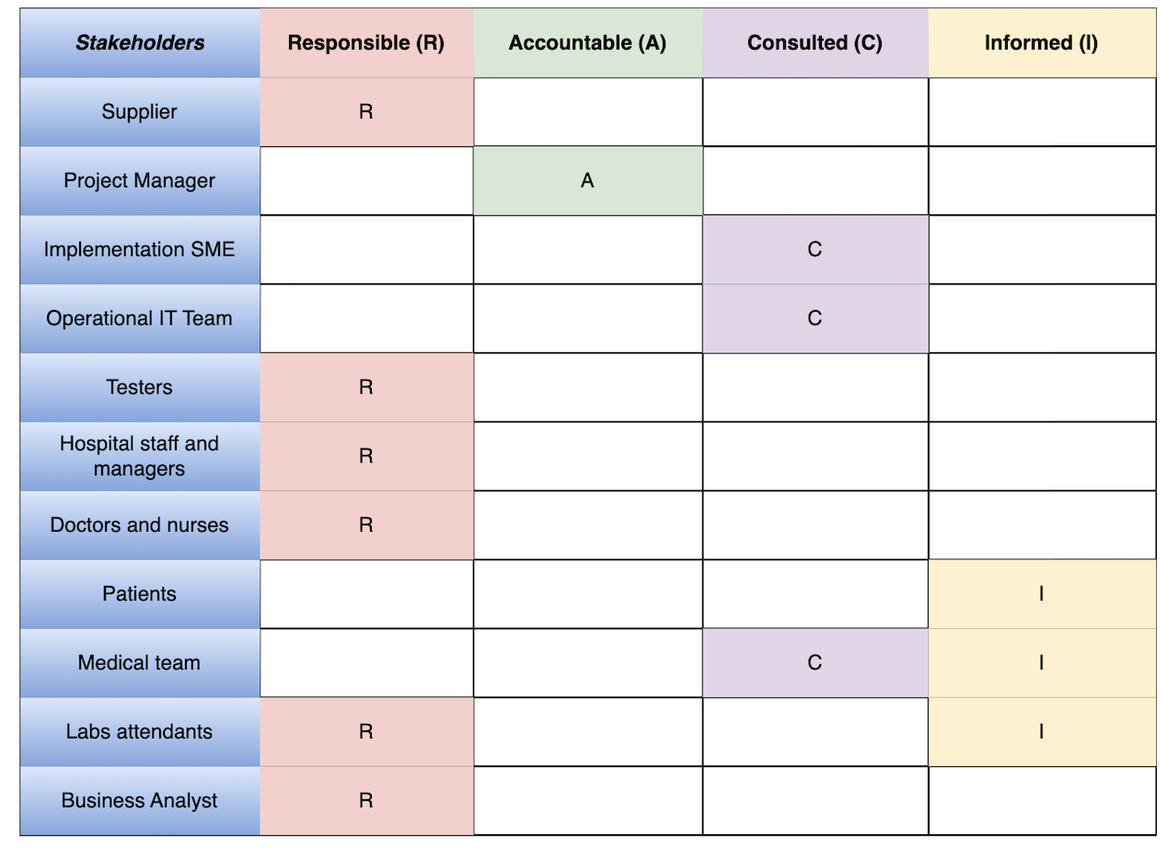

# **Task 2: Proposed system workflow**



# **Task 3: In-Scope and Out of Scope items for HMS**

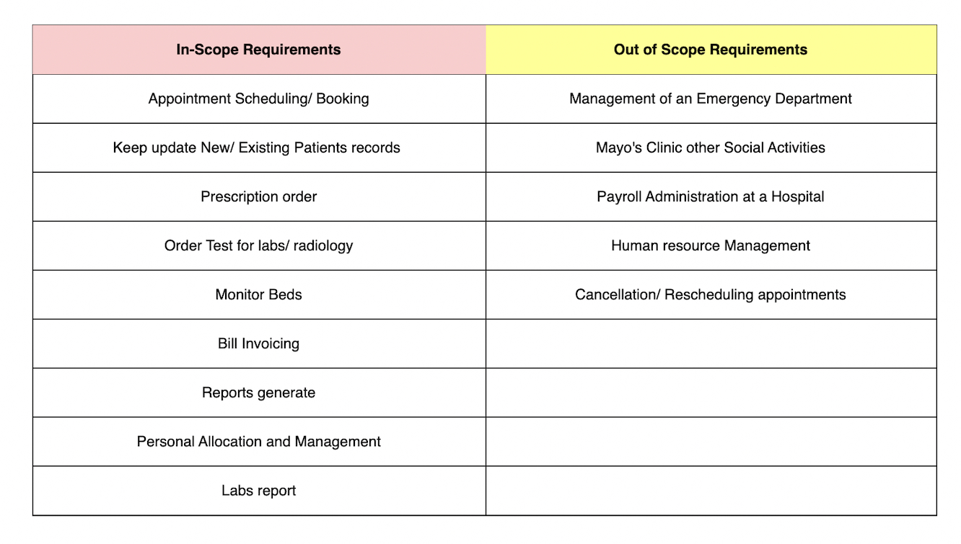

# **Task 4: Scope of Hospital Management (HMS) – UML Diagram**

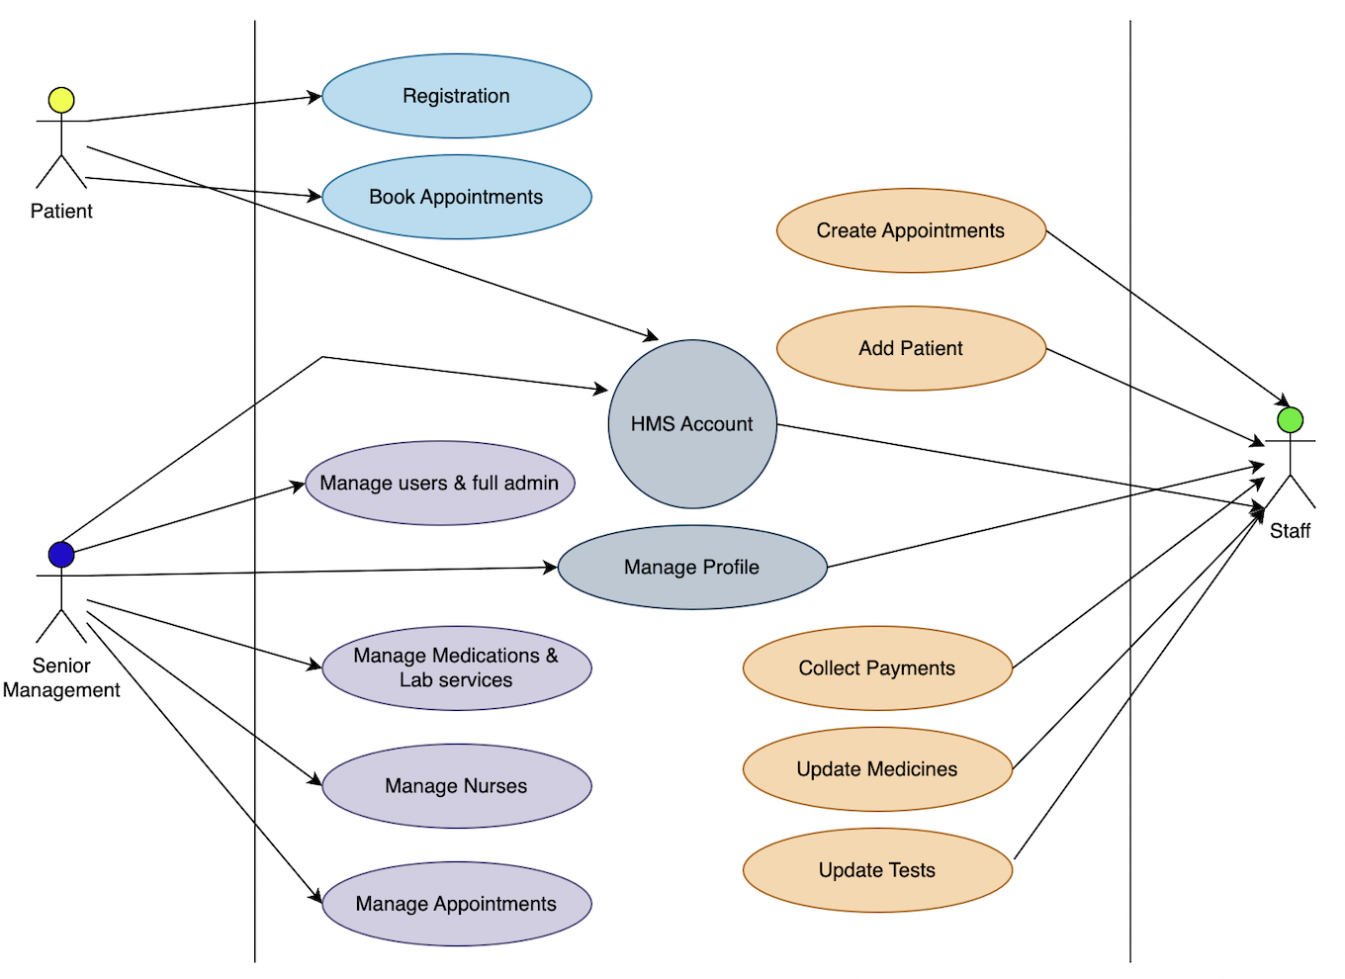

# **Task 5: Main features of the HMS**

* Website-based Management System
* Must be in the MYSQL database and operate with Windows 2016
* Must support the capacity of a minimum of 500 users at a time
* Response time must be within 1 second
* The interface must be interactive and user friendly
* 24/7 available
* Monitor Patient's account/registration
* Appointment Booking/Scheduling/Rescheduling/Cancel
* Keep up to date the patient’s record
* Keep Insurance particulars
* The doctor’s profile needs to be managed and maintained
* Prescription, labs and radiology records
* Allocation records for billing personnel
* Staff management in the hospital
* Monitor the bedding system
* All Bills records
* Reports sent to Senior Management
* Check the Bed section for each day
* Doctor’s appointment and revenue generation through OPDs
* Admitted patients and Total number of OPDs
* Analyse which Doctor generating high revenue
* Check Total profit through OPDs and admitted patients
* Check Total profit through Lab and radiology

# **Task 6: An ER diagram of the system**

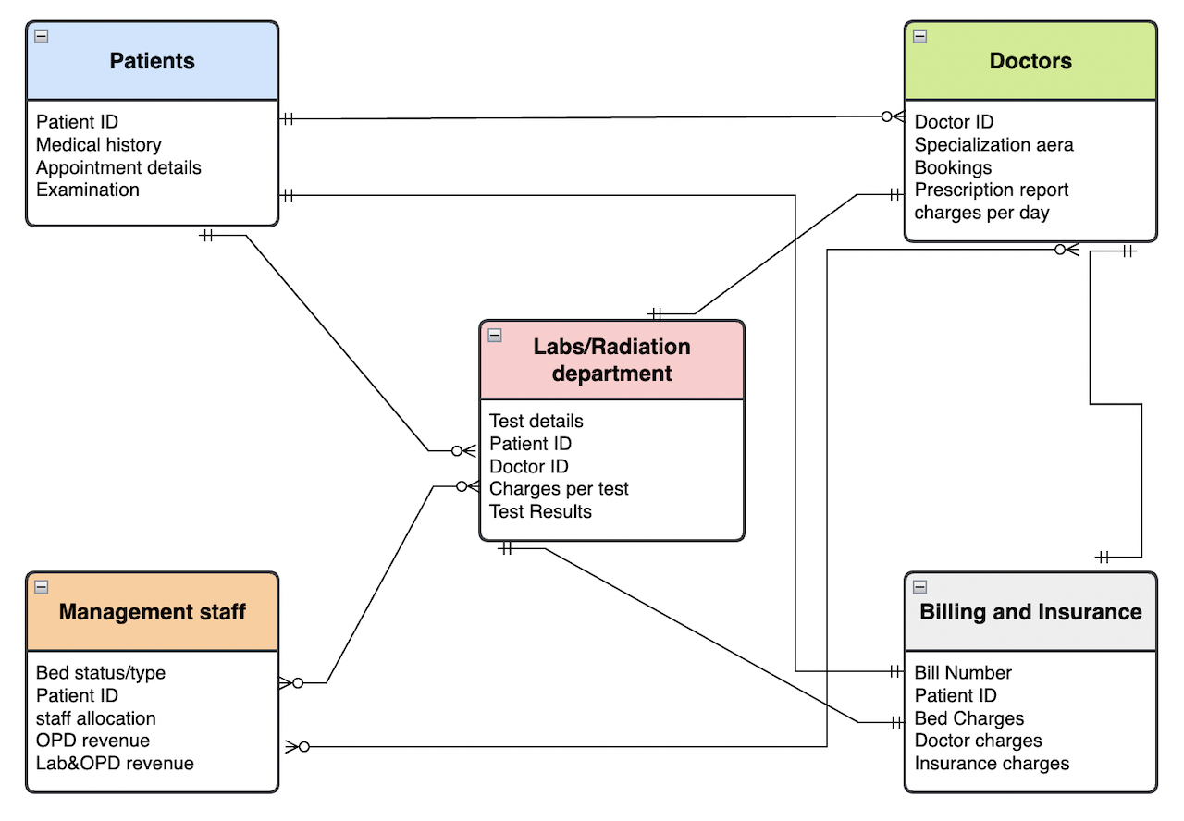

# **Task 7: Data flow diagram for HMS**

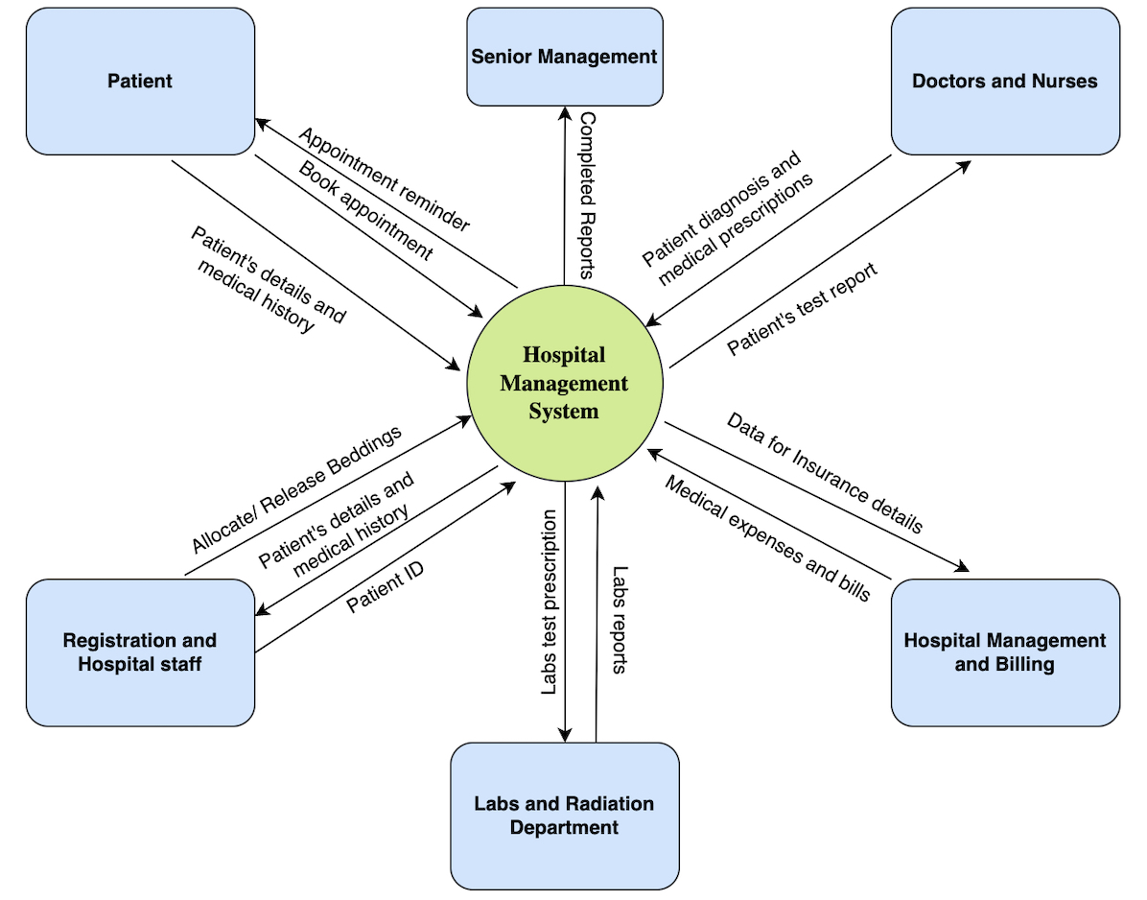

# **Task 8: Functional and Non-Functional requirements for this software**

* Functional Requirements:
* Patients registration page
* Appointment scheduling and notification reminder
* Patient’s medical history and retrieval
* Doctor’s medical prescription
* Lab and Radiology test results page
* Bed Occupancy information
* Staff management and allocation
* Detailed Reports to senior management
* Medical expenses and Billing reports
* Insurance details
* Non-Functional Requirements:
* **MySQL Database:** to be used since it is open source and free.
* **Operating System:** Shall be Windows 2016.
* **Web-based:** The system shall be a web-based application.
* **Response time**: The system shall give responses in 1 second.
* **Capacity**: The system must support 500 people using it at a time.
* **Errors:** The system shall keep a log of all the errors.
* **Availability:** The system shall be available all the time.

# **Task 9: Flowchart for the patient’s admission process**

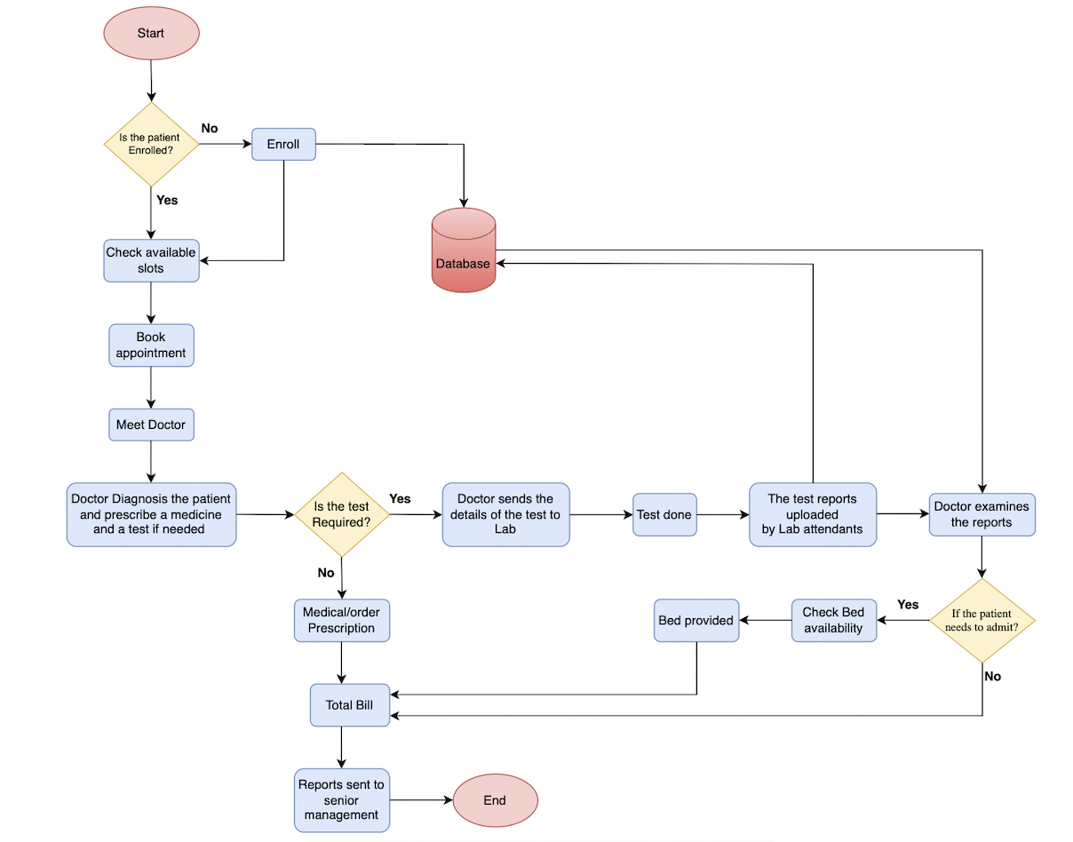

# **Task 10: Wireframes – Home page and Patient’s registration screen**

